**Mockito:**

**Exercise 1: Mocking and Stubbing**

**Scenario:**

You need to test a service that depends on an external API. Use Mockito to mock the external API and stub its methods.

**Steps:**

1. Create a mock object for the external API.

2. Stub the methods to return predefined values.

3. Write a test case that uses the mock object.

**ExternalApi.java:**

package com.example;

public interface ExternalApi {

String getData();

}

**MyService.java:**

package com.example;

public class MyService {

private ExternalApi api;

public MyService(ExternalApi api) {

this.api = api;

}

public String fetchData() {

return api.getData();

}

}

**MyServiceTest.java:**

package com.example;

import static org.junit.jupiter.api.Assertions.*assertEquals*;

import static org.mockito.Mockito.*;

import org.junit.jupiter.api.Test;

public class MyServiceTest {

*@Test*

public void testExternalApi() {

// Step 1: Create mock

ExternalApi mockApi = *mock*(ExternalApi.class);

// Step 2: Stub method

*when*(mockApi.getData()).thenReturn("Mock Data");

// Step 3: Inject mock into service

MyService service = new MyService(mockApi);

// Act

String result = service.fetchData();

// Assert

*assertEquals*("Mock Data", result);

}

}

**Output:**

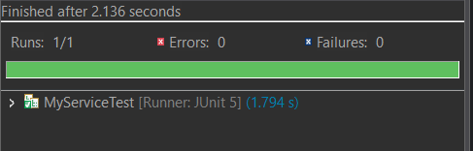

**Exercise 2: Assertions in JUnit**

**Scenario:**

You need to ensure that a method is called with specific arguments.

**Steps:**

1. Create a mock object.

2. Call the method with specific arguments.

3. Verify the interaction.

**Step 1 was completed in previous exercise , now only changing MyServiceTest.java.**

**MyServiceTest.java:**

package com.example;

import static org.mockito.Mockito.*;

import org.junit.jupiter.api.Test;

public class MyServiceTest {

*@Test*

public void testVerifyInteraction() {

// Step 1: Mock the API

ExternalApi mockApi = *mock*(ExternalApi.class);

// Step 2: Use it in your service

MyService service = new MyService(mockApi);

service.fetchData();

// Step 3: Verify that getData() was called exactly once

*verify*(mockApi).getData();

}

}

**OUTPUT:**

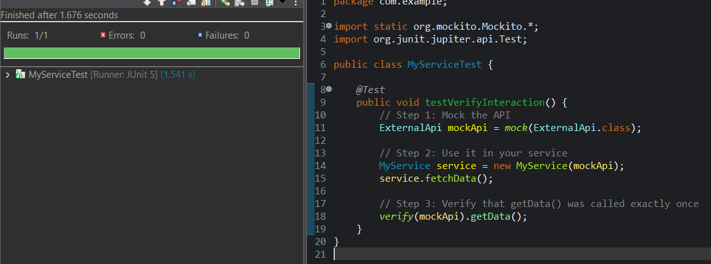

**SLF4J:**

**Exercise 1: Logging Error Messages and Warning Levels using SLF4J in Eclipse with Maven.**

**Task:**

Write a Java application that demonstrates logging error messages and warning levels using SLF4J.

**Steps:**

1. Add SLF4J and Logback dependencies to your `pom.xml` file:

<dependency>

<groupId>org.slf4j</groupId>

<artifactId>slf4j-api</artifactId>

<version>1.7.30</version>

</dependency>

<dependency>

<groupId>ch.qos.logback</groupId>

<artifactId>logback-classic</artifactId>

<version>1.2.3</version>

</dependency>

2. Create a Java class that uses SLF4J for logging:

import org.slf4j.Logger;

import org.slf4j.LoggerFactory;

public class LoggingExample {

private static final Logger logger = LoggerFactory.getLogger(LoggingExample.class);

public static void main(String[] args) { logger.error("This is an error message"); logger.warn("This is a warning message");

}

}

**pom.xml:**

<project xmlns="http://maven.apache.org/POM/4.0.0"

xmlns:xsi="http://www.w3.org/2001/XMLSchema-instance"

xsi:schemaLocation="http://maven.apache.org/POM/4.0.0

http://maven.apache.org/xsd/maven-4.0.0.xsd">

<modelVersion>4.0.0</modelVersion>

<groupId>com.example</groupId>

<artifactId>junit_demo</artifactId>

<version>0.0.1-SNAPSHOT</version>

<packaging>jar</packaging>

<name>JUnit Demo Project</name>

<dependencies>

<dependency>

<groupId>junit</groupId>

<artifactId>junit</artifactId>

<version>4.13.2</version>

<scope>test</scope>

</dependency>

<!-- JUnit 5 -->

<dependency>

<groupId>org.junit.jupiter</groupId>

<artifactId>junit-jupiter</artifactId>

<version>5.9.3</version>

<scope>test</scope>

</dependency>

<!-- Mockito -->

<dependency>

<groupId>org.mockito</groupId>

<artifactId>mockito-core</artifactId>

<version>5.10.0</version>

<scope>test</scope>

</dependency>

<!-- SLF4J API -->

<dependency>

<groupId>org.slf4j</groupId>

<artifactId>slf4j-api</artifactId>

<version>1.7.30</version>

</dependency>

<!-- Logback as SLF4J backend -->

<dependency>

<groupId>ch.qos.logback</groupId>

<artifactId>logback-classic</artifactId>

<version>1.2.3</version>

</dependency>

</dependencies>

<build>

<plugins>

<plugin>

<groupId>org.apache.maven.plugins</groupId>

<artifactId>maven-surefire-plugin</artifactId>

<version>3.0.0-M5</version>

</plugin>

</plugins>

</build>

</project>

**LoggingExample.java:**

package com.example;

import org.slf4j.Logger;

import org.slf4j.LoggerFactory;

public class LoggingExample {

private static final Logger logger = LoggerFactory.getLogger(LoggingExample.class);

public static void main(String[] args) {

logger.error("This is an error message");

logger.warn("This is a warning message");

logger.info("This is an info message");

}

}

**OUTPUT:**

